Q7 Interview Scheduling

**Problem Statement**:    
Our recruiters need an efficient and streamlined way to schedule interviews with candidates. The current manual process involves back-and-forth communication to find suitable time slots, leading to delays and potential miscommunication. We want to automate the interview scheduling process within the Recruitment App, allowing recruiters to easily send interview invitations.

**Solution Design**:

Functional Requirements:

1. Interview Scheduling Trigger:  
The interview scheduling process should be from the Job Application record layout page on clicking a schedule Interview button and assigning the recruiter as the interviewer.

2. Email Notifications:  
The system should automatically send email notifications to both the selected candidate(s) and the assigned interviewer.

The email notifications should include:

Candidate's name and contact information   
Interviewer's name  
Proposed interview date and time  
Interview location (if applicable)  
Any additional instructions or preparation materials.

This should be fetched from the Position object’s new field named : Additional Instructions / Preparation materials.

Technical Requirements:

Salesforce Flow:

* Develop a screen-Flow to ease the interview scheduling process.
* The Flow should be initiated by a custom button or action on the Job Application object's page layout.

Utilize Flow elements to:

* Retrieve the selected Job Application record and their associated Candidate and create a job Interview record (new Custom Object).
* Prompt to select an interview date and time.
* Generate and send email notifications to the candidate and the interviewer using email templates.
* The candidate should be pre-populated by default with candidate of the Job Application on which the button was clicked.

Email Templates:

* There should be two different email Templates. One for the Candidate and the other for the recruiter.
* Design email templates for interview invitations containing candidate details , recruiter name and the schedule when the interview
* schedule details.

Solution Process:  
  
1. Custom Object: Job Interview | Create a custom object called Job Interview.

Fields for the Job Interview object:

Application (Lookup): Links to the Job Application record.  
Candidate (Lookup): Links to the Candidate record (can be populated automatically from the Job Application).  
Interviewer (Lookup): Links to the Interviewer(User object).  
Interview Date (DateTime): Date and time of the interview.  
Location (Text): Specifies the location of the interview.  
Additional Instructions (Long Text): Pulled from the Position object. Other relevant fields as required.

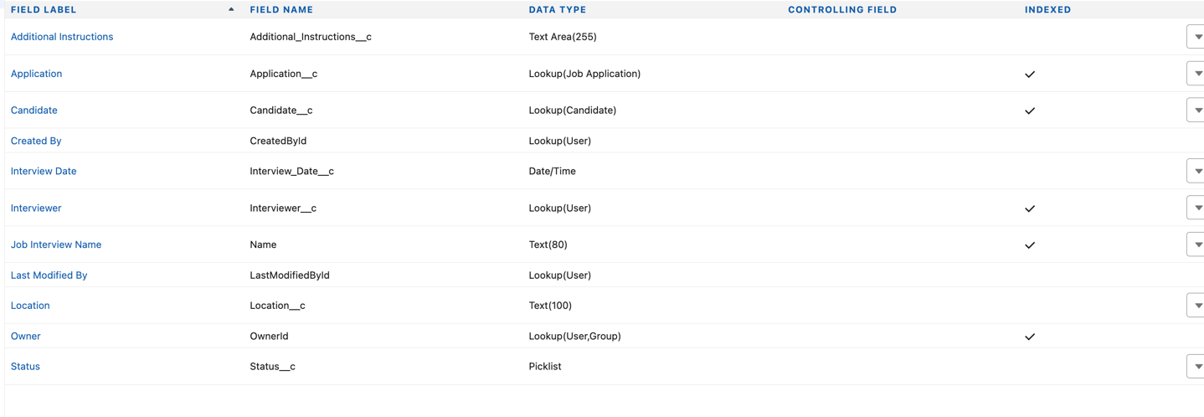

2. Button/Action on Job Application

Add a Custom Button or Quick Action on the Job Application object.  
Custom Button: Use to trigger the flow from the page layout.  
Quick Action: Use to make the process accessible in the Lightning Experience.  
  
  
3. Flow Design

Use a Screen Flow to guide the recruiter through the interview scheduling process.

Flow Steps:

Start Element: The flow should be triggered by the button/action.

Get Records:

* Fetch the Job Application record based on the record ID passed when the button is clicked.
* Retrieve the associated Candidate and Position record.

Screen Element:

* Pre-populate the Candidate field with the candidate from the Job Application.
* Allow the recruiter to select the interview date, time, and location.
* Display additional instructions from the Position record.
* Create Job Interview Record:
* Use a Create Records element to create a Job Interview record with the entered details.

Send Email Notifications:

* Use Action elements to send emails to both the Candidate and the Recruiter.
* Utilize pre-designed Email Templates with merge fields to populate the relevant details.

4. Confirmation Screen:

Display a confirmation message to the recruiter indicating the interview has been scheduled successfully.

4. Email Templates

Create two email templates:

* Candidate Email Template: Includes candidate name, interview date/time, location, and any preparation instructions.
* Recruiter Email Template: Includes recruiter name, candidate details, and the scheduled interview information.

5. Add Button/Action to Page Layout

Place the custom button or action on the Job Application page layout. Ensure that the necessary fields are visible to recruiters.  
  
  
  
  
  
  
  
  
Here is the Interview-Schedule Flow .   
  
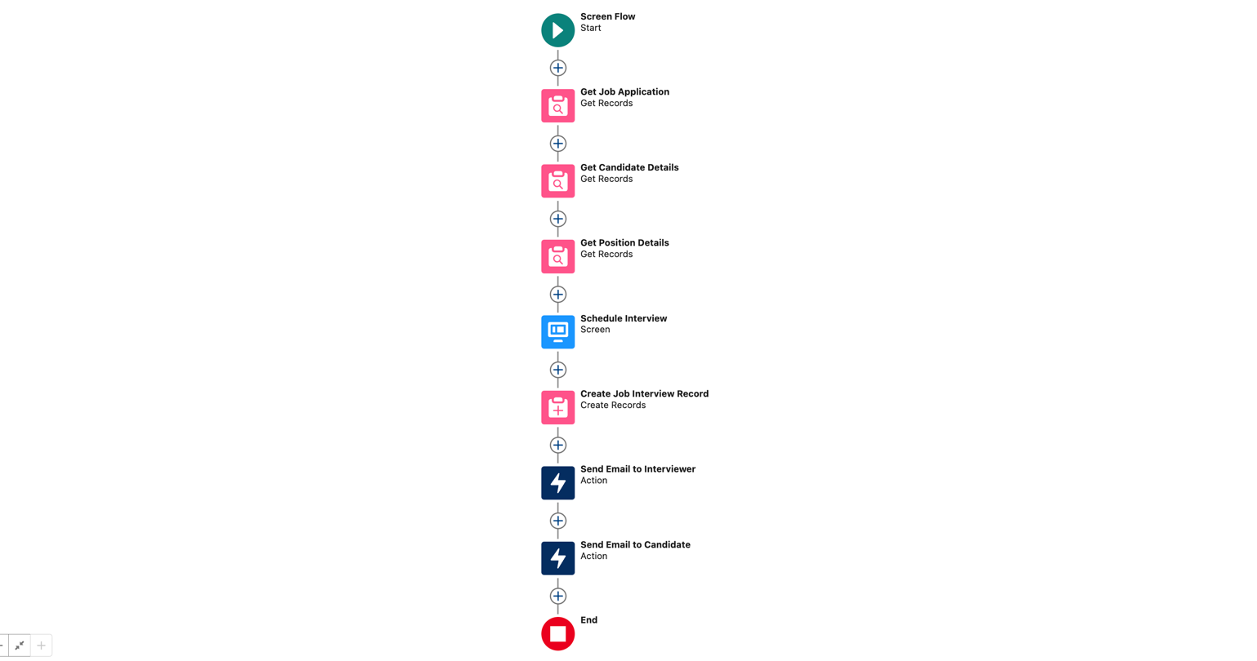  
  
 Screen :  
  
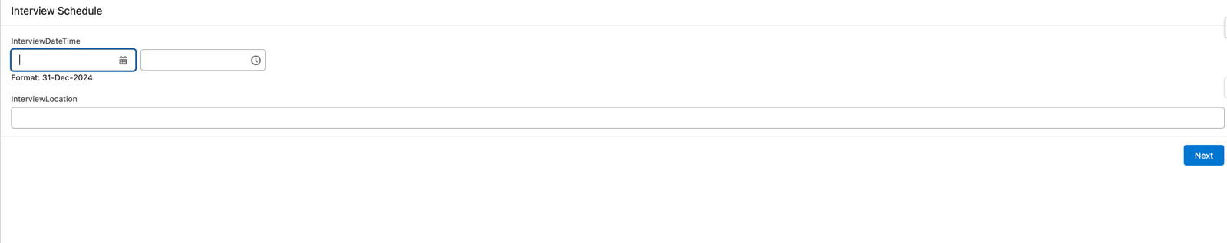

Emails For Candidate:  
  
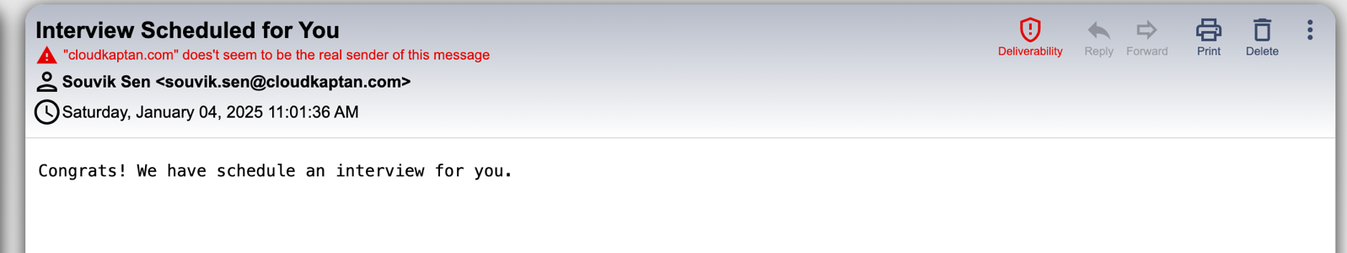

Emails For Interviewer:

